**PUB CLASSICS**

Available Tuesday – Saturday Lunch & Tuesday – Thursday Dinner

**Terrine of pork & apricot**

piccalilli, croutons £16

**Nut Tree prawn cocktail**

apple, celery, avocado, preserved lemon £18

**Today’s soup** £12

**\*\*\***

**Onglet steak from Aubrey Allen – cooked medium rare**

Nut Tree chips, peppercorn sauce £32

**Beer battered fish**

Nut Tree chips, curry gravy, tartare sauce £30

**Pearl barley ‘risotto’**

spring vegetables, olives, gran kinara £28

**Side dishes** – Nut Tree chips, Nut Tree Garden leaves with honey mustard dressing - £8 each

**\*\*\***

**Raspberry souffle**

Nut Tree Garden raspberry sorbet, chambord custard£18

**Sticky toffee pudding**

toffee sauce, caramel apple, vanilla ice cream£16

**Nut tree Garden rhubarb pannacotta**

macerated strawberries, strawberry sorbet £17

**Artisan cheese**

Nut Tree crackers, red onion compote £25 – may be taken as an extra course before or after dessert

**We can also offer full size dishes from the tasting menu**

**Please ask for prices.**

We are very proud of the suppliers we use at The Nut Tree

They offer us excellent quality raw produce with sustainability and traceability

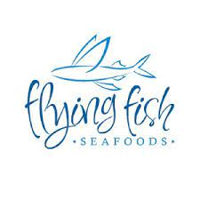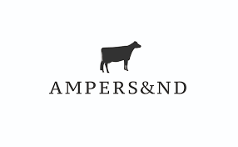



 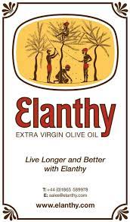 

**We do use nuts, gluten and other allergens**

**If you have any dietary requirements you must make us aware before ordering**

10% optional service charge will be added to all parties of 6 or more